FitBuddy-AI — AI-Powered Personalized Workout & Nutrition Planner
Final Project Report
FitBuddy-AI — AI-Powered Personalized Workout & Nutrition Planner
Date | 24/09/2026
Team ID | SWTID-2026-9413
Team Size | 4
Project Name | FitBuddy-AI
Team Leader: Praveenkumar J | Team Members: Praveen, PremAnand R, Susibala A

Description
FitBuddy-AI is a secure-by-design, self-contained, AI-powered web application developed to simplify fitness planning and provide intelligent, personalized workout guidance. Built using Python, FastAPI, SQLAlchemy, and SQLite, the application exposes both a Jinja2-rendered web interface and REST APIs that enable profile capture, AI-generated workout plans, nutrition tips, and feedback-driven plan refinement.
The application follows a layered architecture, separating configuration, persistence, validation, AI logic, and routing into dedicated modules, which keeps the project modular, maintainable, and easy to extend. Every incoming request is validated through Pydantic schemas before it reaches the database, and all profile and plan data is stored using SQLAlchemy over SQLite.
One of the key features of the project is its integration with Google Gemini, which generates a personalized 7-day workout plan and a nutrition tip based on a user's age, weight, goal, and training intensity. When a user submits feedback on their plan, the AI service layer builds a follow-up prompt that incorporates the original plan and the feedback to produce a revised plan, rather than starting over. A built-in demo mode ensures the entire flow works end-to-end even without a configured Gemini API key, which keeps local development, testing, and demonstration simple.
The backend returns both rendered HTML pages and standardized JSON responses, making it suitable for direct browser use as well as integration with other clients. Input validation, centralized configuration, and a small admin dashboard for managing registered users round out the application.

Scenario-Based Case Study

Background
Aarav is a fitness beginner who wants to start exercising but does not know which workouts suit his age, weight, and goal. He has tried generic plans from the internet before, but they never adapt to how his training is actually going, and he has no easy way to get them adjusted.

Problem
- Difficulty finding a workout plan tailored to his specific age, weight, and goal
- No professional guidance available without paying for a personal trainer
- No simple way to adjust a plan once it stops matching how his training is progressing
- No record of past plans or profile information to build on over time

Solution
- Aarav fills in a short profile form on FitBuddy-AI with his name, age, weight, goal, and training intensity
- The backend validates the input and calls Google Gemini to generate a personalized 7-day workout plan and a nutrition tip matching his goal
- His profile and generated plan are saved automatically in SQLite, so returning with the same user ID updates rather than duplicates his profile
- When a particular day feels too intense, Aarav submits short feedback describing the issue, and FitBuddy-AI returns an updated plan that takes it into account

Requirement Analysis
Requirements were grouped into functional areas — profile capture and validation, AI workout plan generation, AI nutrition tips, feedback-driven updates, an admin dashboard, and a REST API — alongside non-functional requirements covering usability, reliability (via demo mode), security of input handling, and maintainability of the layered codebase. Full detail is provided in the Requirement Analysis Phase documents (Solution Requirements, Technology Stack, Data Flow Diagram & User Stories).

Project Design
The system was designed as a layered application: a presentation layer (Jinja2 templates and a JSON API), an application layer (FastAPI routes and Pydantic schemas), a service layer (the Gemini-backed AI module with its demo-mode fallback), and a data layer (SQLAlchemy models and CRUD functions over SQLite). This separation keeps AI logic, persistence, and request handling independent of one another, which made the project easier to build incrementally and test.
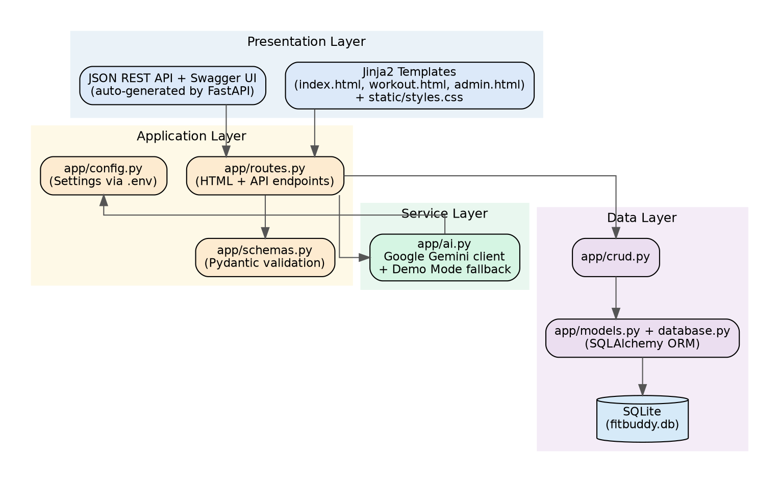

Project Planning & Scheduling
Work was organized into four sprints: backend and database setup, validation and the CRUD/configuration layer, Gemini integration with the feedback loop and web routes, and finally the REST API, admin dashboard, and testing/documentation. Full sprint-by-sprint story points and ownership are recorded in the Project Planning Phase document.

Coding and Solutioning
The backend was implemented in a modular app package: config.py for environment-driven settings, database.py and models.py for SQLAlchemy persistence, schemas.py for Pydantic validation, crud.py for database operations, ai.py for the Gemini-backed AI service with its demo-mode fallback, and routes.py for both the HTML and JSON endpoints. Full module-by-module detail is recorded in the Project Development Phase document.

Testing
The team executed a User Acceptance Testing pass covering profile validation, plan and nutrition-tip generation in both demo and live Gemini modes, the feedback loop, the admin dashboard (including the disabled-admin case), the REST API endpoints, and the health check. All planned test cases passed; full detail is recorded in the Project Testing Phase document.

Results
The completed application lets a user go from an empty profile form to a personalized 7-day workout plan and nutrition tip in a single request, refine that plan with a short piece of feedback, and — for an administrator — view and manage every user who has used the tool. The same functionality is available through documented JSON endpoints for other clients to integrate against.

Advantages and Disadvantages

Advantages
- No account or login required — a user ID alone is enough to save and retrieve a profile and its plans
- Demo mode allows the full application to be evaluated without any external API cost
- Layered structure keeps AI, persistence, and routing concerns independent and easy to test
- Same core logic is reachable through a human-friendly web UI and a machine-friendly REST API

Disadvantages
- No authentication means anyone who knows or guesses a user ID could view or update that profile
- SQLite is well suited to a single-instance deployment but not to concurrent multi-server writes at scale
- Plan quality in live mode depends on the Gemini model's output and is not clinically reviewed

Conclusion
FitBuddy-AI successfully demonstrates how a small, layered FastAPI application can combine straightforward data validation and persistence with a generative AI service to produce genuinely personalized, iteratively refinable fitness guidance, while remaining simple enough to run, test, and demo without any paid dependency.

Future Scope
- Add optional authentication so a profile can only be viewed or updated by its owner
- Track workout completion and progress over time, not just the generated plan text
- Support PostgreSQL for multi-instance deployments using the existing configurable DATABASE_URL
- Add richer AI fitness insights derived from logged workout history, not just the initial profile

Appendix
Source Code: available in the project's Code_File package (FastAPI app, templates, tests, and setup documentation).
Demo Video: [Add link once recorded]
GitHub Repository: [Add repository link]

